

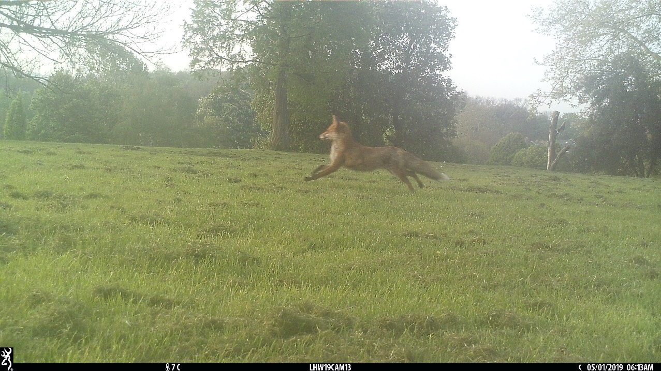

Brockwell Park Camera Trap Survey

24th April- 16th May 2019

Introduction

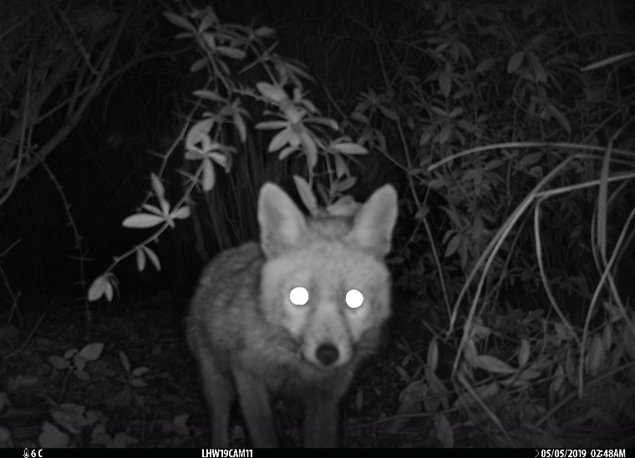
Urban greenspaces can be a haven for wildlife¹, however relatively little is known about distribution and activity of the animals using these spaces. Urban foxes are perhaps the most familiar, but hedgehogs and in certain areas of London, badgers, may be present. Hedgehogs are of most concern, as the UK population is declining dramatically, falling by a third since 2000. Interestingly, this decline seems most rapid in rural rather than urban areas², highlighting the importance of city greenspace for wildlife. In order to promote wildlife in these places, information is needed about the populations that currently exist.
A current ZSL project named London HogWatch is aiming to survey London parks with camera traps to collect this information about London’s remaining hedgehog populations. The cameras at Brockwell were set according to the method this project uses.
Brockwell Park was surveyed using two methods, visual surveying with camera traps and audible surveying with AudioMoths. Camera trapping provides information on predominantly mammals using a park, such as foxes and hedgehogs, whereas the AudioMoths record bird and bat activity (with this survey specifically aimed at monitoring parakeets). This report is concerned with the results from the camera trapping.
Figure 1: Fox image taken during the Brockwell Park survey.

Method

Brockwell Park was surveyed from the 24th April to the 16th May 2019, resulting in 510 nights of data. The entirety of the greenspace was monitored using 30 Browning Strike Force Pro camera traps (Figure 2). The traps were set to trigger and take a photo every second if an animal entered the detection zone of the camera. Use of infrared flash allowed the cameras to be active at night as well as day. To ensure even coverage of the greenspace cameras were placed as close as possible to a predetermined grid pattern.
Cameras were placed by staff from ZSL and local volunteers from the Friends of Brockwell Park. Ideal site coordinates generated by computer were uploaded to Google’s MyMaps, allowing the use of smartphone GPS to locate the camera sites. Where the generated sites were placed in unsuitable areas, with nothing to attach the camera to, the camera was placed as close as possible to that point.
Only photos taken between the hours of 6pm and 8am were processed, as the species of interest (hedgehogs and foxes) are predominantly nocturnal. This restricted tagging interval also has the benefit of avoiding much of the human activity the cameras detect. Once tagged, the data was used to calculate trapping rates (number of sightings/numbers of nights the camera was active) for each site and species. These trapping rates allow comparison between camera sites and provide a measure of activity across the park. Maps generated from this data are provided in the results section.

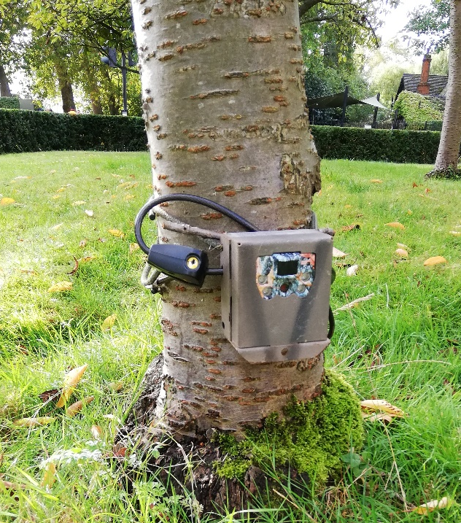

Figure 2: Browning Strike Force Pro camera traps used in the surveys. Cameras were enclosed in a metal box and locked to a tree to protect against theft.

Results

The most common wild species detected by the cameras were foxes, with 662 sightings and a trapping rate of 1.3 (Table 1). Unfortunately, no hedgehogs were detected by the cameras, so it is highly unlikely that there is a permanent population in the park.
Other mammal species recorded by the cameras were squirrels, rats, cats, one rabbit and a high number of dogs. Common bird species were also seen.

Table 1: Results from the survey of Brockwell park. Cameras were active for a total of 510 nights between them. 30 cameras were placed, however only 29 could be retrieved. Trapping rate is no. of sightings/ no. nights active.
Species | Number of Sightings  (6pm-8am) | Number of Sites Present (%) | Overall Trapping Rate
Dog | 1391 | 28 (97) | 2.73
Fox | 662 | 27 (93) | 1.30
Squirrel | 21 | 8 (28) | 0.04
Cat | 3 | 2 (7) | 0.006
Rat | 2 | 1 (3) | 0.004
Rabbit | 1 | 1 (3) | 0.002
Hedgehog | 0 | 0 (0) | 0

Camera traps collect information on both the spatial and temporal activity of a species. The map below (Figure 3) shows the distribution of fox sightings across the park. Coloured circles show species presence and white absence. Larger circles indicate a higher trapping rate and therefore more activity at that site. Foxes were widely distributed across the park, being absent at only two of the 29 sites. Activity varied significantly (from 0 to 5.4), with highest rates found towards the northern end of the park.

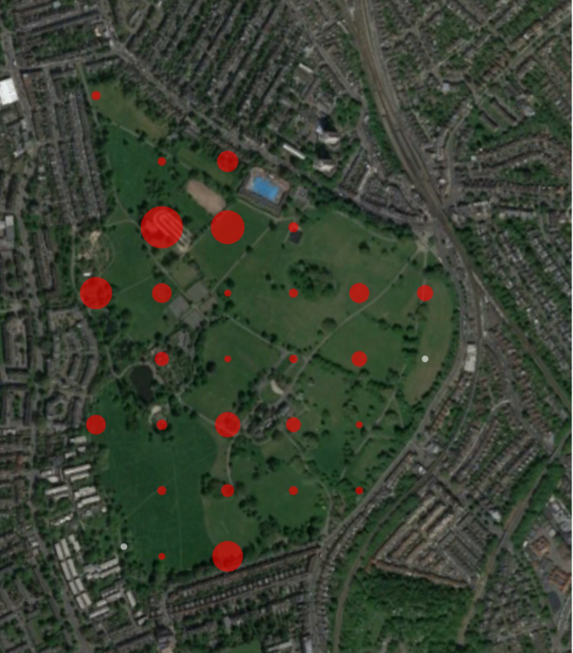
Figure 3: Fox distribution across Brockwell Park. Red indicates presence and white absence. Larger circles represent higher trapping rates, ranging from 0 to 5.4.

The graph below (Figure 4) shows the temporal activity of foxes in the park, looking at the proportion of activity occurring through the night. Two distinct peaks can be seen. The first is around 11:30pm, after which activity drops again. The second occurs at around 4am, before dropping back to nearly 0 at around 7am.

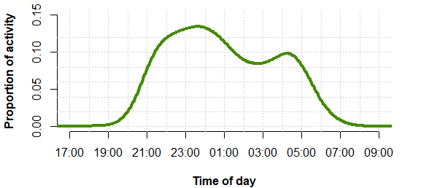
Figure 4: Temporal activity of foxes in Brockwell Park. Photos were only tagged between the hours of 6pm and 8am.

The map below shows the distribution of dog sightings across the park (Figure 5), with some sites recording very high levels of activity.
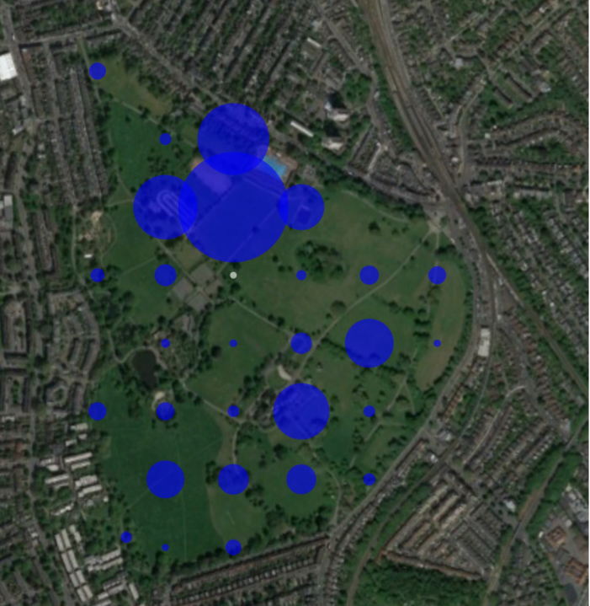
Figure 5: Dog distribution across Brockwell Park. Blue indicates presence and white absence. Larger circles represent higher trapping rates, ranging from 0 to 15.2.

Discussion

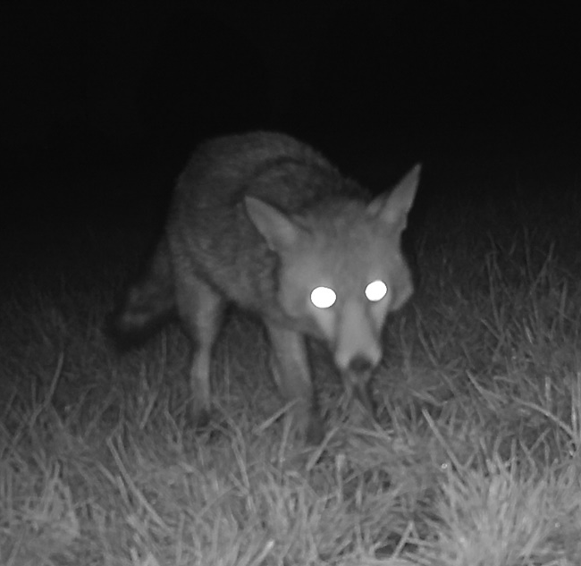
As expected, foxes were abundant in the park. Urban parks can support high density populations, as surrounding housing provides a readily available food source. The cameras also revealed some fox behaviour as photos were taken of foxes foraging for earthworms (Figure 6), although the most significant component of their diet is likely to be scavenging anthropogenic food³.
The pattern of temporal activity of the foxes at Brockwell is similar to that found in other parks, having two distinct peaks. Recent work on London HogWatch data has suggested that this could coincide with foxes leaving and then re-entering the parks after searching for food in the surrounding residential areas. Other parks surveyed found higher trapping rates around the boundaries of the parks, presumably due to this movement in and out of the parks, but this does not seem to be the case in Brockwell Park.
Figure 6: Fox foraging for earthworms in Brockwell Park.
Although no hedgehogs were seen in the park itself, citizen science records from the London Wildlife Trust and the Peoples Trust for Endangered Species Hedgehog Street project show that they are present in the surrounding area (Figure 7⁴). One main issue for urban hedgehogs is the difficulty of accessing potential habitat due to large roads⁵, which may explain why they are not seen in the park. Even if hedgehogs had been present, a larger area would be needed to support a sustainable population, area that could be provided by private gardens. This is achievable through making small holes in fences to improve connectivity and making other small changes to ensure gardens are friendly to wildlife. Connecting surrounding gardens may help to boost the local hedgehog population and enable them to colonise the park in the future.
To help monitor the status of hedgehogs, any sightings (alive or dead) can be reported to the Big Hedgehog Map (https://bighedgehogmap.org/) or the London Wildlife Trust (https://www.wildlondon.org.uk/campaign/record-your-sightings/hedgehog).
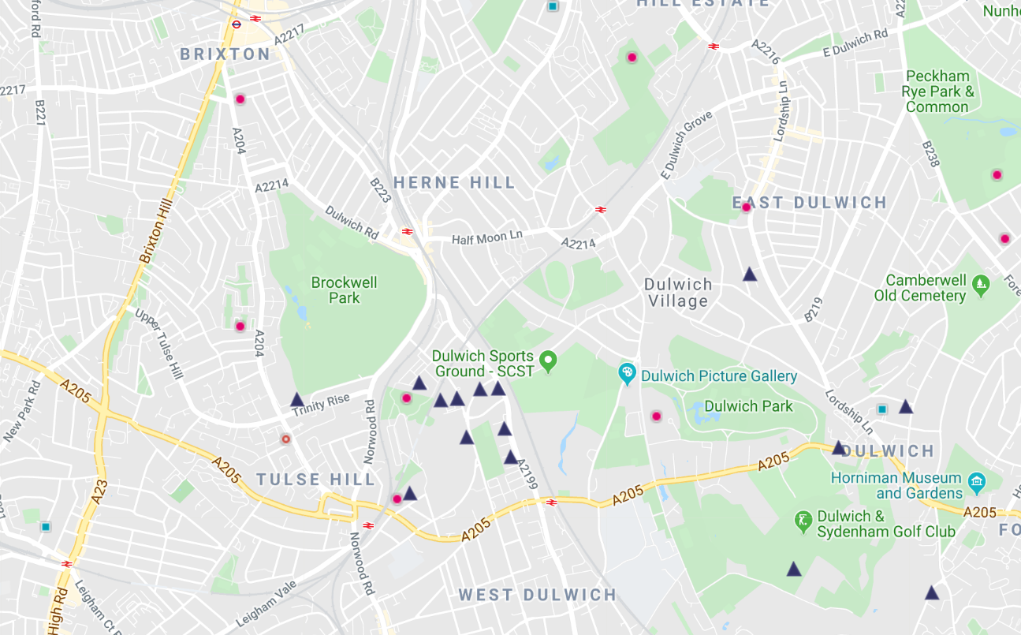
Figure 7: Citizen science hedgehog sightings around Brockwell Park. Taken from https://bighedgehogmap.org/. Both circle and triangle symbols are sightings.

London HogWatch has now conducted several surveys in south London, including Dulwich Park and Peckham Rye Park and Common. No hedgehogs were seen in Dulwich, and only one was recorded in Peckham Rye. Hedgehogs have also been patchy in other areas of London, so unfortunately Brockwell Park is not unusual in having no hedgehogs present. A summary of survey results is provided in Table 2. The fox trapping rate of 1.3 found at Brockwell Park was high when compared to other London greenspaces that have been surveyed, although less than the 3.1 recorded at Dulwich and 1.82 at Peckham Rye.

Table 2: Results from all the greenspaces London HogWatch has surveyed.
Park | Hedgehog |  |  |  | Fox |  |  | Badger
Park | Contact events |  | Camera Sites  (total) | Overall Trapping Rate | Contact events | Camera Sites  (%) | Overall Trapping Rate | Contact events | Camera Sites | Overall Trapping Rate
Alexandra Park (2017) | 63 | 8 (9) |  | 0.0616 | 1196 | 71 (84) | 1.17 | 0 | 0 (0) | 0
Barnes Common (2018) | 19 | 7 (24) |  | 0.032 | 499 | 26 (90) | 0.823 | 12 | 3 (10) | 0.02
Barnes Common (2019) | 16 | 7 (26) |  | 0.02 | 632 | 22 (81) | 0.81 | 4 | 3 (11) | 0.005
Bank of England Sports Club (2019) | 0 | 0 (0) |  | 0 | 2255 | 7 (100) | 11.56 | 98 | 5 (71) | 0.50
Brockwell Park  (2019) | 0 | 0 |  | 0 | 662 | 27 | 1.33 | 0 | 0 | 0
Bushy Park (2017) | 1 | 1 (7) |  | 0.003 | 174 | 14 (93) | 0.58 | 3 | 3 (20) | 0.01
Dulwich Park  (2019) | 0 | 0 (0) |  | 0 | 921 | 20 (100) | 3.1 | 0 | 0 (0) | 0
Golders Hill  (2017) | 202 | 25 (83) |  | 0.326 | 1046 | 30 (100) | 1.687 | 0 | 0 (0) | 0
Hampstead Heath (2018) | 380 | 73 (47) |  | 0.17 | 2027 | 131  (87) | 0.91 | 1 | 1 (1) | 0.0004
Highgate Wood  (2017) | 1 | 1 (2) |  | 0.0016 | 239 | 33 (75) | 0.379 | 0 | 0 (0) | 0
Home Park (2018) | 0 | 0 (0) |  | 0 | 492 | 88 (60) | 0.244 | 506 | 64 (44) | 0.289
Peckham Rye Park and Common  (2019) | 1 | 1 (4) |  | 0.002 | 774 | 27 (96) | 1.82 | 0 | 0 (0) | 0
Queen’s Wood  (2017) | 0 | 0 (0) |  | 0 | 582 | 34 (97) | 1.0172 | 0 | 0 (0) | 0
Palewell Common (2019) | 0 | 0 (0) |  | 0 | 334 | 12 (86) | 0.84 | 162 | 10 (71) | 0.41
Regent’s Park (2016) | 73 | 18 (26) |  | 0.0788 | 744 | 65 (96) | 0.8026 | 0 | 0 (0) | 0
Richmond Park (2018) | 0 | 0 (0) |  | 0 | 122 | 25 (78) | 0.355 | 240 | 19 (59) | 0.698
Roehampton Golf Club (2019) | 0 | 0 (0) |  | 0 | 868 | 30 (100) | 0.88 | 74 | 19 (63) | 0.08
Russia Dock Woodland  (2019) | 0 | 0 (0) |  | 0 | 534 | 14 (93) | 2.58 | 0 | 0 (0) | 0
WWT London Wetland Centre  (2019) | 62 | 13 (45) |  | 0.15 | 552 | 22 (76) | 1.36 | 0 | 0 (0) | 0

Conclusion

The camera trap survey of Brockwell Park has revealed that it supports an abundant population of foxes, with the trapping rate being significantly higher than in many other greenspaces in London. No hedgehogs were seen during survey, nor are they recorded as being inside the park by citizen science projects. However, there has been a number of sightings in the area around the park, suggesting that hedgehogs may be able to colonise in the future, if efforts are made to improve connectivity between greenspaces and access to more habitat, such as private gardens to boost numbers.
There is a possibility that a repeat survey of Brockwell Park could be conducted in the spring of 2020.

References

1. Wembridge, D. & Langton, S. Living with Mammals: an urban study. British Wildlife 189–195 (2016).
2. Wilson, E. & Wembridge, D. The State of Britain’s Hedgehogs 2018. https://www.britishhedgehogs.org.uk/pdf/sobh-2018.pdf.
3. Bateman, P. W. & Fleming, P. A. Big city life: Carnivores in urban environments. Journal of Zoology 287, 1–23 (2012).
4. BIG Hedgehog Map. https://bighedgehogmap.org/.
5. Rondinini, C. & Doncaster, C. P. Roads as barriers to movement for hedgehogs. Functional Ecology 16, 504–509 (2002).

